

./



GENESIS – SDLC MiniProject

**Document History**

|  |  |  |  |  |  |
| --- | --- | --- | --- | --- | --- |
| **Ver.Rel. No.** | **Release Date** | **Prepared. By** | Reviewed By | To Be Approved By | Remarks/Revision Details |
| 1 | 07.12.20 | Alen V George  Sagar Jadhav  P Ramya |  |  |  |
|  |  |  |  |  |  |
|  |  |  |  |  |  |
|  |  |  |  |  |  |
|  |  |  |  |  |  |

Contents

1. INTRODUCTION: 6

2. REQUIREMENTS: 6

2.1 AGEING AND COSTING: 6

2.2. SWOT ANALYSIS: 8

2.3 HIGH LEVEL REQUIREMENTS: 9

2.4 LOW LEVEL REQUIREMENTS: 9

3. SYSTEM DESIGN: 11

3.1 High level UML Diagrams: 11

3.1.1 Use Case Diagram: 11

3.1.2 Class Diagram: 12

3.1.3 Component Diagram 13

3.1.4 State Diagram: 13

3.2. Low Level UML Diagram 14

ACTIVITY DIAGRAM: 14

3.2.1Arithmetic: 14

3.2.2 Conversions 15

3.2.3 Trigonometric: 16

4. TEST PLAN: 17

LIST OF TABLES

Table 1: High level requirements 8

Table 2: Low Level Requirements 9

Table 3: Test Plan 17

TABLE OF FIGURES

Figure 1: Costing and Ageing 8

Figure 2: SWOT Analysis 9

Figure 3: Use Case Diagram 12

Figure 4: Class Diagram 13

Figure 5: Component Diagram 14

Figure 6: State Diagram 14

Figure 7: Arithmetic Activity Diagram 15

Figure 8: Conversions Activity Diagram 16

Figure 9: Trigonometric Activity Diagram 17

**ACTIVITY-5**

**CALCULATOR**

# 1. INTRODUCTION:

The purpose of the project was to design a scientific a calculator. A calculator is a device that performs arithmetic operations on numbers. The simplest calculators can do only addition, subtraction, multiplication, and division. The scientific calculator includes many functions like roots, logarithms, trigonometric functions, hyperbolic functions, conversions including arithmetic operations.

# 2. REQUIREMENTS:

## **2.1 AGEING AND COSTING:**

Nowadays the demand for Automatic and simple applications increasing regularly. Everywhere and every person requires a tool to ease his/her efforts. In each phase, we provide few functions which can be used to performs complex and simple operations. User can choose whatever he/she wish to perform.

The cost of this application is mostly free to use, but to use some additional functionalities, like keeping track of contact details in databases and maintaining servers need some cost. Which will be the monetizing factor

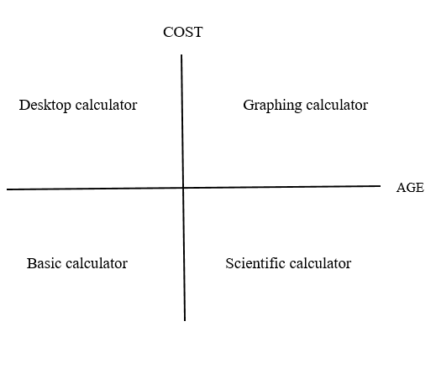

Figure 1: Costing and Ageing

## **2.2. SWOT ANALYSIS:**

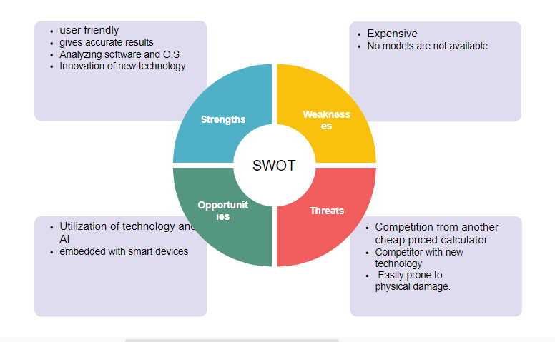

Figure 2: SWOT Analysis

## **2.3 HIGH LEVEL REQUIREMENTS:**

Table 1: High level requirements

|  |  |
| --- | --- |
| **ID** | **Requirements** |
| HL_01 | Calculator has to produce a correct result |
| HL_02 | Calculator should be able to do all calculations |
| HL_03 | The calculator is developed using standard C++ language and should run on all machines supporting g++ compiler. |

## **2.4 LOW LEVEL REQUIREMENTS:**

Table 2: Low Level Requirements

|  |  |  |
| --- | --- | --- |
| **ID** | **Requirement** | **Description** |
| LL_01 | Add | The calculator must be able to perform addition |
| LL_02 | Subtract | The calculator must be able to perform substraction |
| LL_03 | Multiply | The calculator must be able to perform multiplication |
| LL_04 | Divide | The calculator must be able to perform division |
| LL_05 | Square | The calculator must be able to perform square |
| LL_06 | Square root | The calculator must be able to perform square root |
| LL_07 | Celsius to Fahrenheit | The calculator must be able to convert Celsius to fahrenheit |
| LL_08 | Fahrenheit to Celsius | The calculator must be able to convert Fahrenheit to Celsius |
| LL_09 | Kilometre to meter | The calculator must be able to convert Kilometer to meter |
| LL_10 | Meter to Kilometer | The calculator must be able to convert Meter to Kilometer |
| LL_11 | Kilogram to Gram | The calculator must be able to convert Kilogram to Gram |
| LL_12 | Gram to Kilogram | The calculator must be able to convert Gram to kilogram |
| LL_13 | Sine | The calculator must be able to perform sine function |
| LL_14 | Cos | The calculator must be able to perform cos function |
| LL_15 | Tan | The calculator must be able to perform tan function |
| LL_15 | Cosec | The calculator must be able to perform cosec function |
| LL_16 | Cot | The calculator must be able to perform Cot function |
| LL_17 | Sec | The calculator must be able to perform Sec function |

# 3. SYSTEM DESIGN:

## **3.1 High level UML Diagrams:**

### 3.1.1 Use Case Diagram:

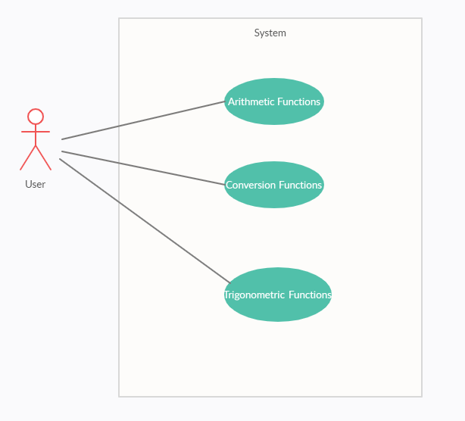

Figure 3: Use Case Diagram

3.1.2 Class Diagram: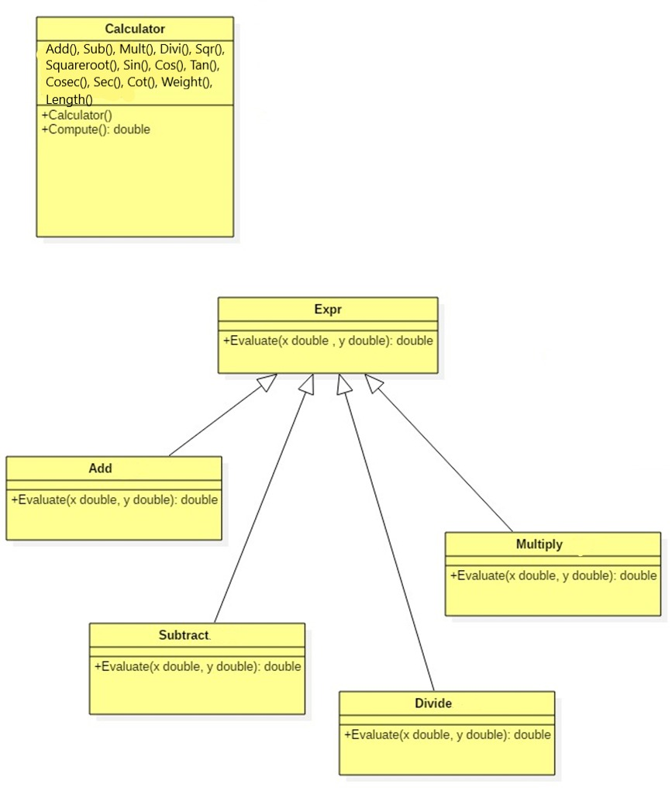

Figure 4: Class Diagram

3.1.3 Component Diagram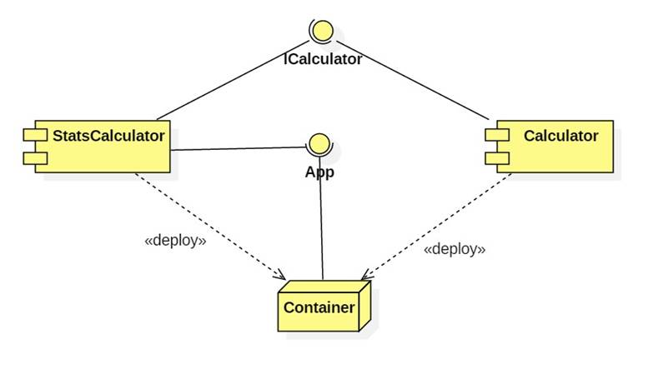

Figure 5: Component Diagram

### 3.1.4 State Diagram:

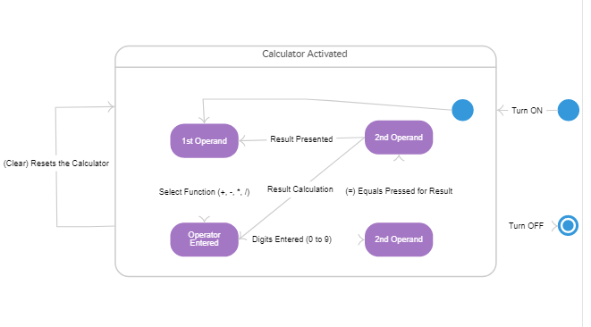

Figure 6: State Diagram

## **3.2. Low Level UML Diagram**

## ACTIVITY DIAGRAM:

### 3.2.1Arithmetic:

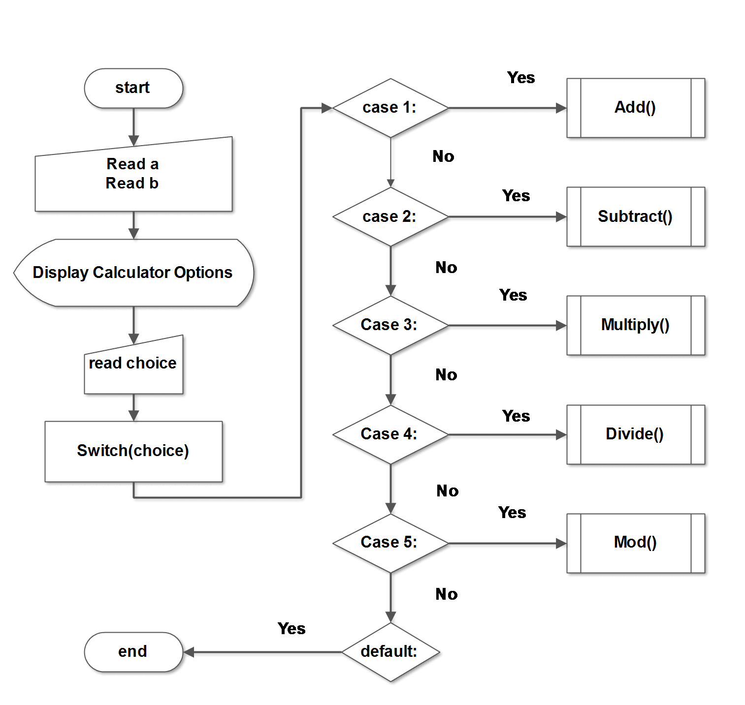

Figure 7: Arithmetic Activity Diagram

### 3.2.2 Conversions

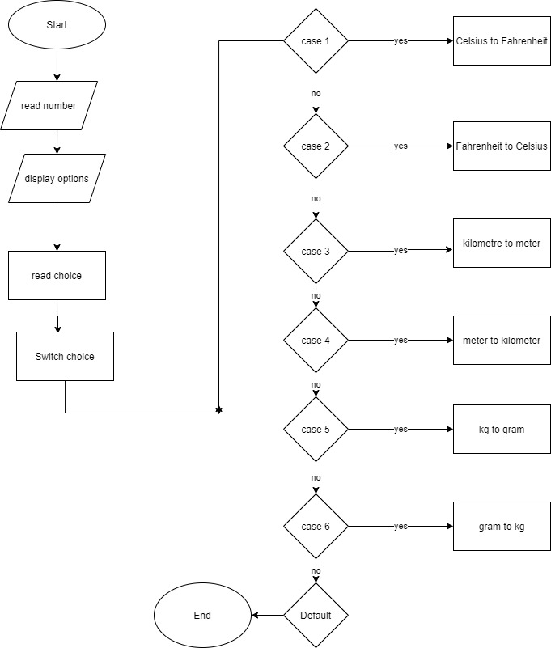

Figure 8: Conversions Activity Diagram

### 3.2.3 Trigonometric:

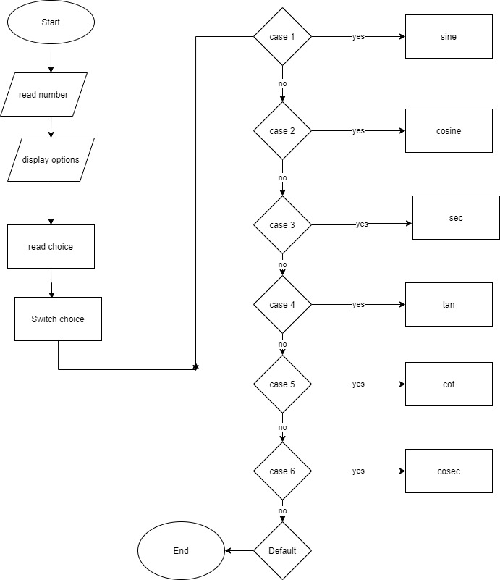

Figure 9: Trigonometric Activity Diagram

# 4. TEST PLAN:

Table 3: Test Plan

|  |  |  |  |
| --- | --- | --- | --- |
| **Test ID** | **Description** | **Input** | **Expected output** |
| TU01 | Addition of two numbers | Number1=5, Number2=10 | 15 |
| TU02 | Subtraction of two numbers | Number1=18, Number2=4 | 14 |
| TU03 | Multiplication of two numbers | Number1=7, Number2=7 | 49.000 |
| TU04 | Division of two numbers | Number1=50, Number2=5 | 10.000 |
| TU05 | Division of a number by zero | Number1=10, Number2=0 | Cannot divide by 0 |
| TU06 | Square root | Input=576 | 24.000 |
| TU07 | Celsius to Fahrenheit | Input=65 | 149.000 |
| TU08 | Fahrenheit to Celsius | Input=149 | 65 |
| TU09 | Kilometre to meter | Input=73 | 73000.000 |
| TU10 | Meter to kilometre | Input=9867 | 9.867 |
| TU11 | Kg to gram | Input=67 | 67000.000 |
| TU12 | Gram to Kg | Input=76000 | 76.000 |
| TU12 | sine | Input=45 | 0.707106 |
| TU13 | cosine | Input=20 | 0.939693 |
| TU14 | tangent | Input=60 | 1.732000 |
| TU15 | cotangent | Input=90 | 0.000000 |
| TU16 | secant | Input=120 | -2.0000 |
| TU17 | cosecant | Input=28 | 2.130054 |

**5. BADGES:**

https://github.com/99003146/Miniproject-Calculator.git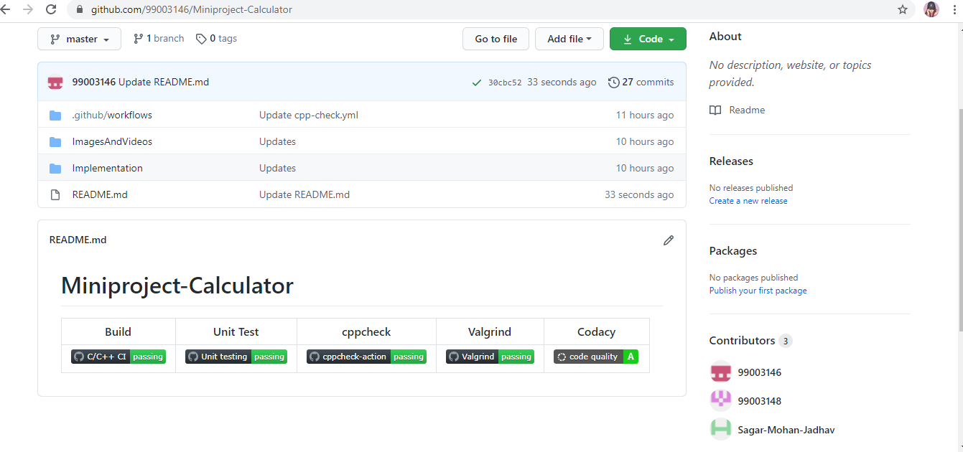

**Link**: <https://github.com/99003146/Miniproject-Calculator.git>